**Settings Menu (Prototype 1)**

1.1 Settings Menu

**Tab** 1. This is the overall template for the Settings UI and maybe the other UI’s in general depending on how useful it is. This **UI will be anchored** to the player’s hand, but will be a few inches away from them (Similar to the Objective tab in Stormlands VR, the game Angel showed us, picture and link of idea below).

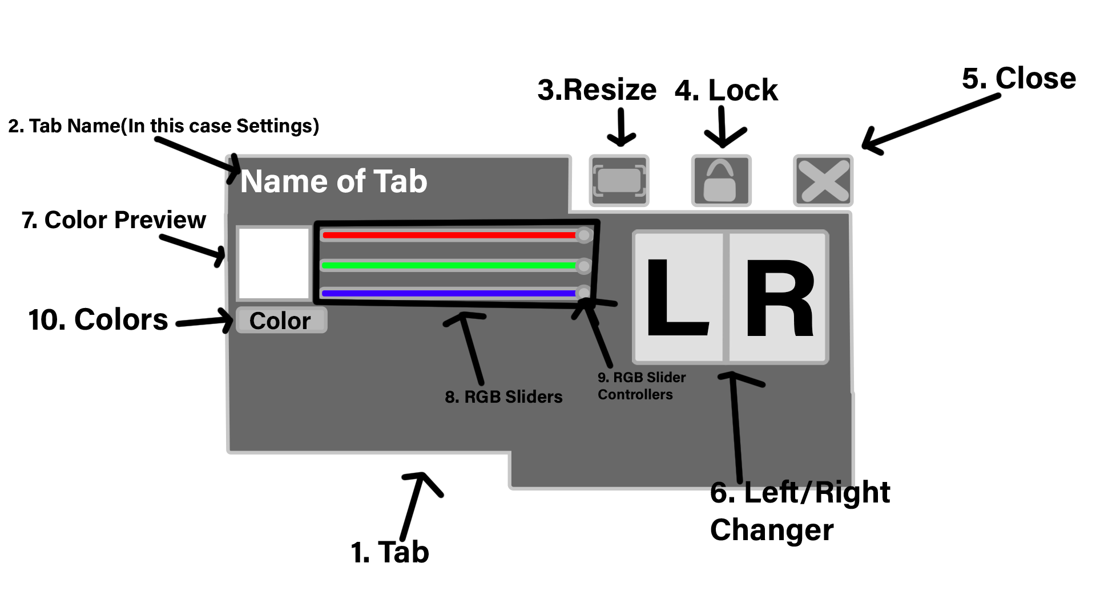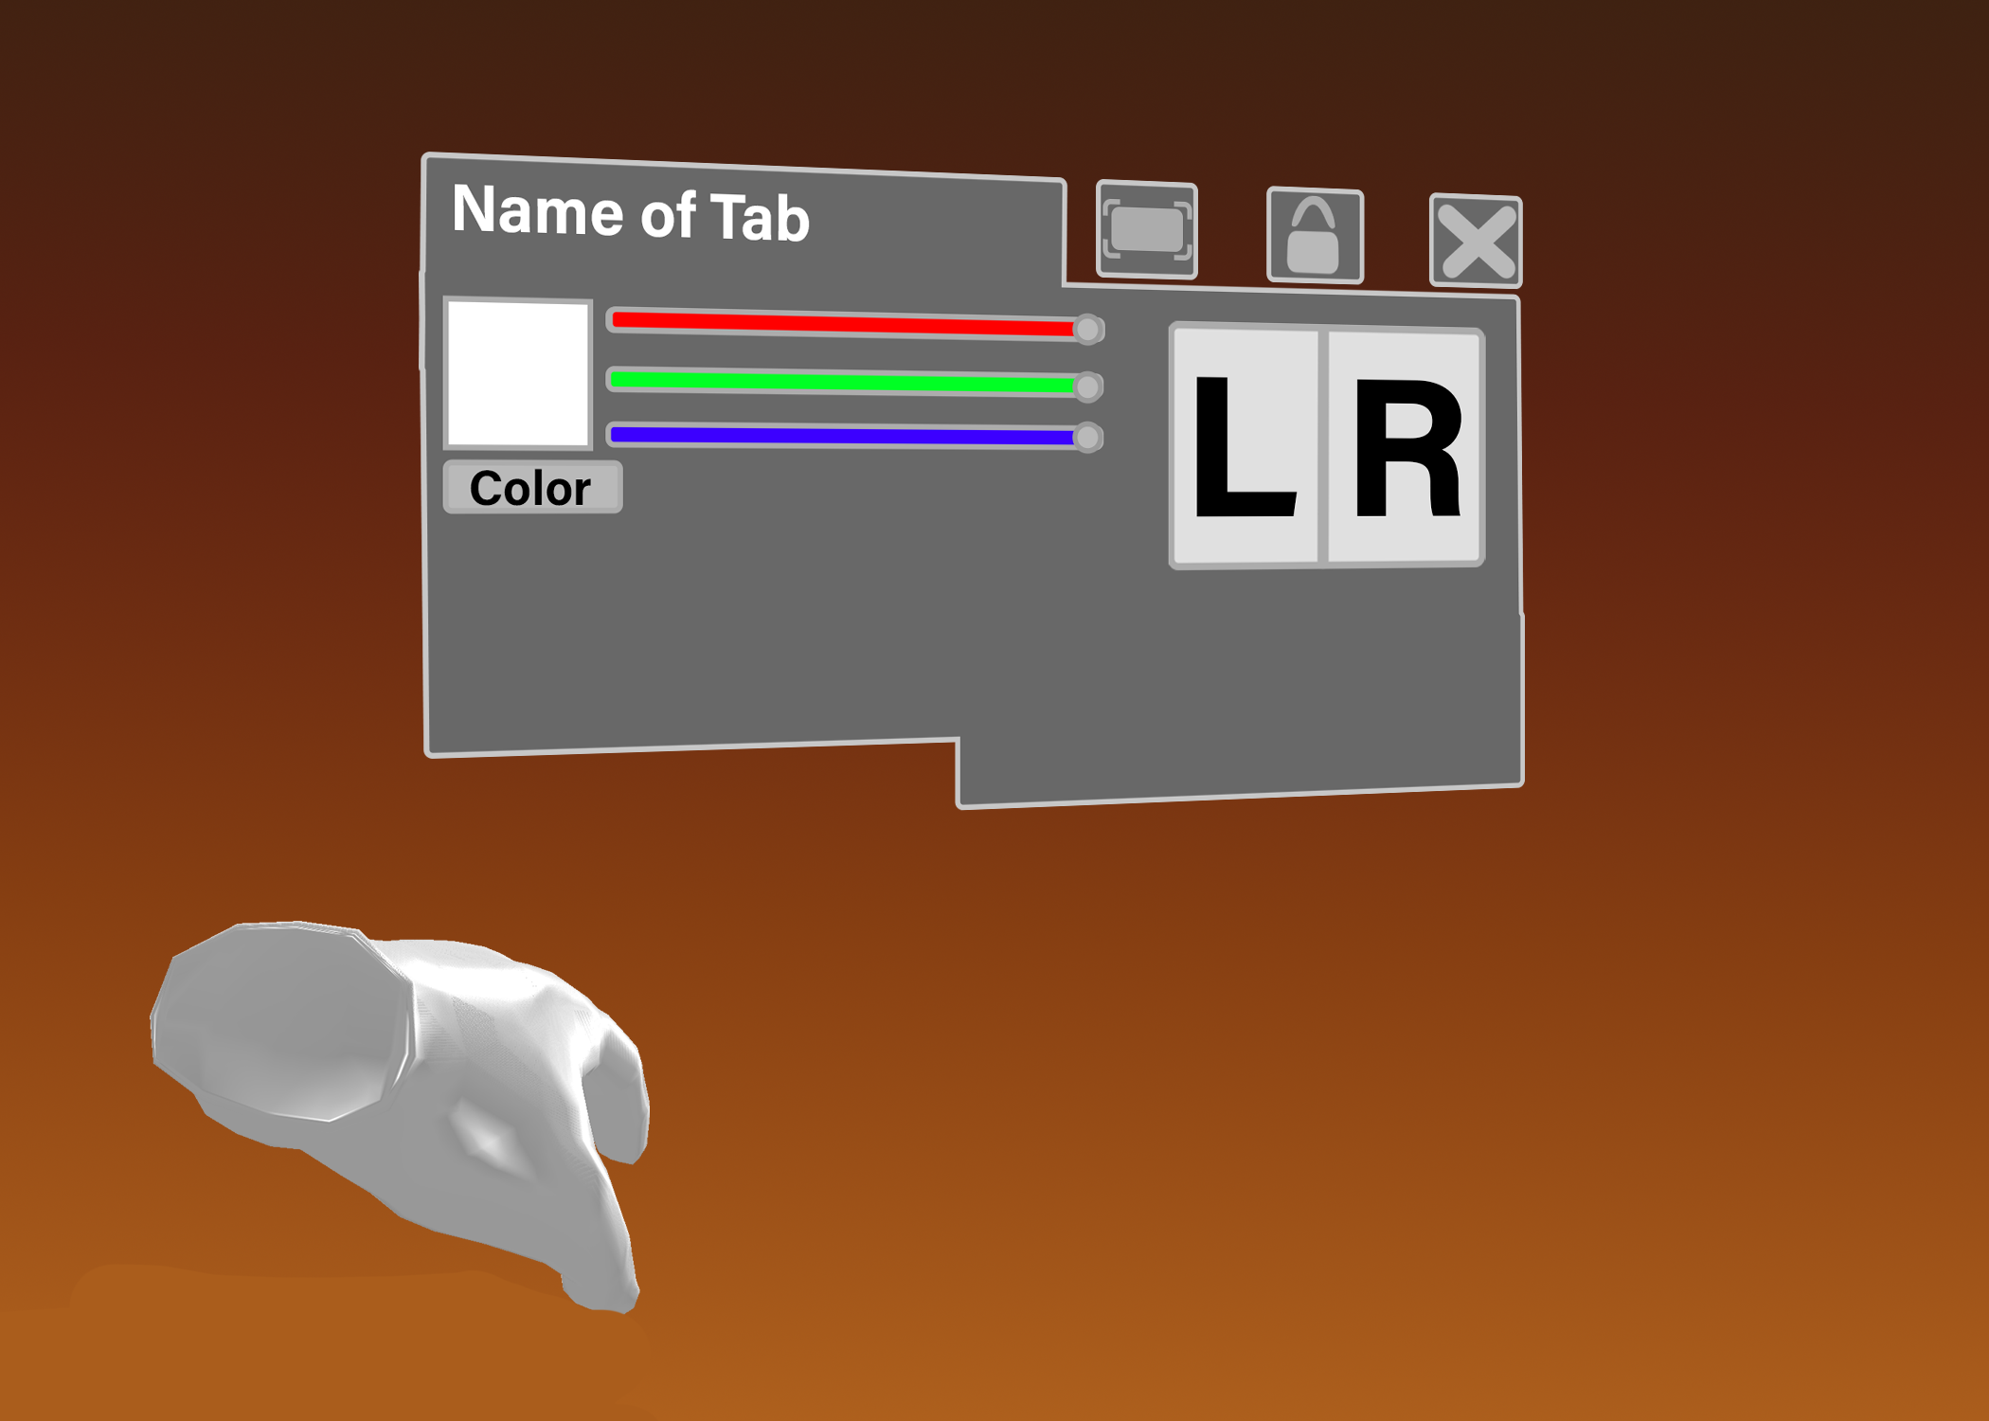

Stormlands VR: <https://youtu.be/pO_rVs3HXRQ?t=650>

If you press the tab itself and not any of the buttons you can move the UI Tab around, but only if the **UI is locked first,** which is discussed on number 4 on the list.

**Name of Tab** 2. This is where the name of the tab/UI is located. In this case, the name of this tab would be **Settings.** *Note: I didn’t call it settings on the photo because I forgot to.*

**Resize** 3. This is the button to resize the UI, but only if the **UI is locked (4)** in place. Once player’s press the resize button, the tab would be darker to indicate that it is in resizing mode. Players can resize it by **putting their hands on one of the corners of the UI** and moving it up and down until the player is pleased. When the player is satisfied with the size, they can **press the button again to exit the resizing settings**.

(This is what it looks like in Resize mode)

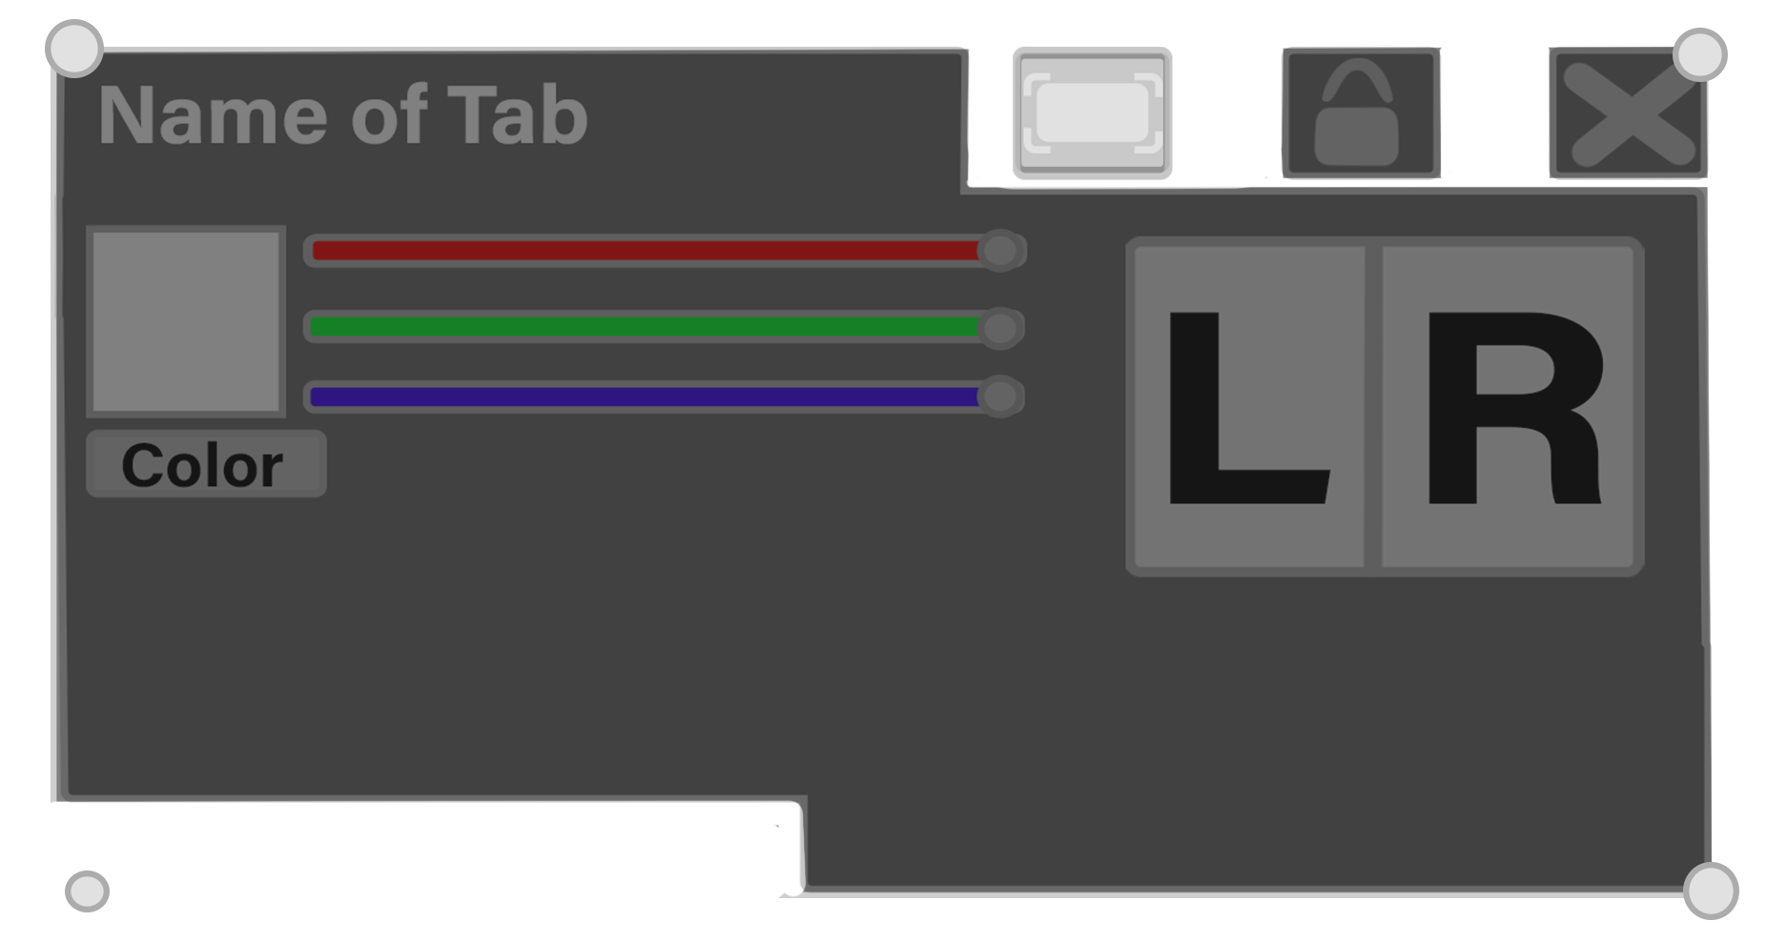

**Lock** 4. This is the button to **lock the UI in place.** When activated, the UI Tab will stay in place, the button will light up like the Resize Button, and not be anchored to the hand of the player. However it will rotate along with the player’s body when the player turns around. When the player presses the UI again, it will unlock and anchor back the player’s arm. It will also go back to its normal color.

**Close** 5. This button closes out the UI tab. When it closes, it should not reset itself from being locked or the size the player has done.

**Left/Right Changer 6**. The two buttons change the panel to fit the needs of people who are left/right handed. The UI would basically flip in the X direction. *Note: I also forgot to add this, but the side it is on would be brighter*

**Color Preview 7.** This square is a purely saturated color that the player has chosen through the RGB Sliders. Whatever, the color they chose, it will be the color of the UI tabs/Menu.

**RGB Sliders 8**. These are sliders that are **controlled by RGB Hand Slider** **Controllers** to change the color of the UI. The color is chosen by sliding the colors based on RGB. *For example, if the Red values are 100 percent, and blue and green are zero, then the rest of the UI colors would be red.* The color can be seen on the Color Preview UI. However, the colors don’t change fonts and the RGB Sliders themselves.